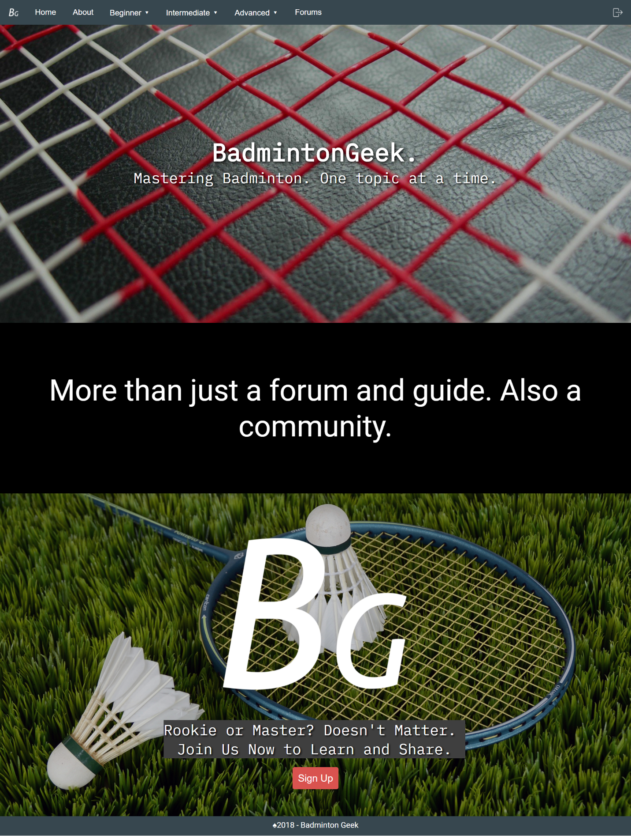

Figure 1:Home

This is the homepage of our website.

On the top of this page, there is a logo of BadmintonGeek followed by the navigation bar that includes Home, About, Beginner, Intermediate, Avanced and Forum. Then, there is a login button at the right side.

The background of the homepage is badminton related pictures. The homepage also shows our website name which is BadmintonGeek with our quote. It introduced to the visitor what is BadmintonGeek in few words. The lowe part of the page has the logo of BadmintonGeek in larger size and a “Sign Up” button.

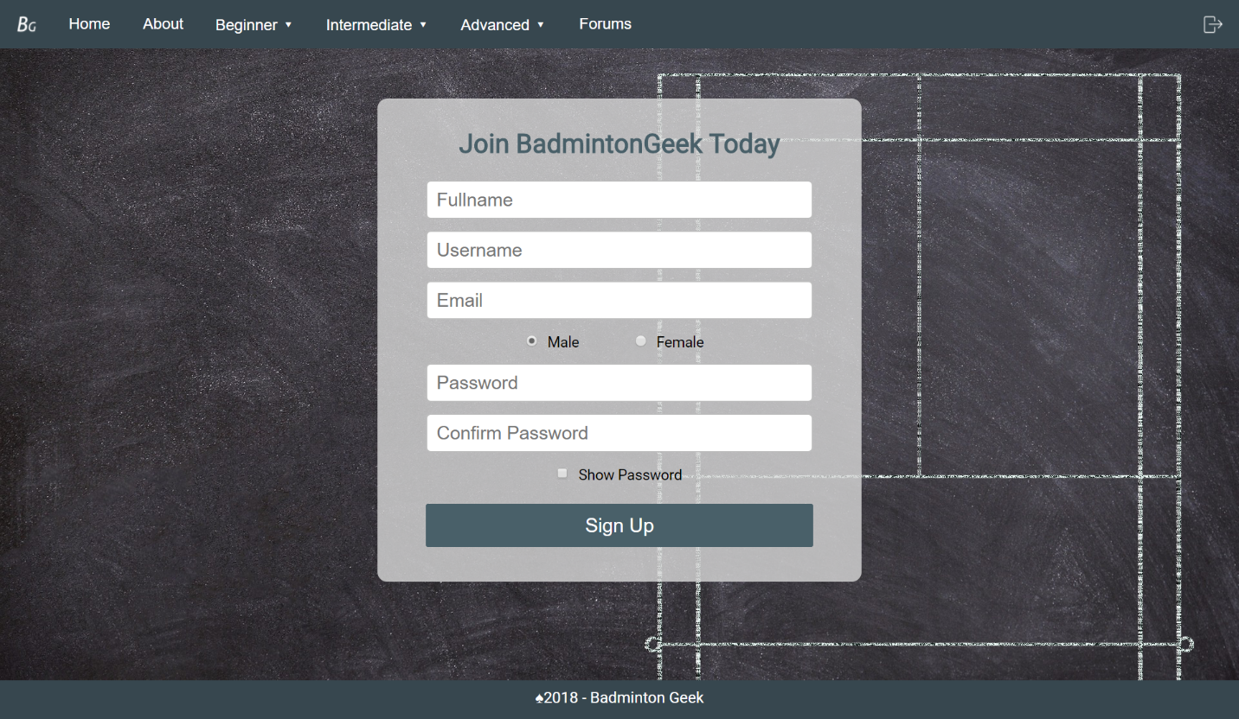

Figure 2: Signup

If the visitor is intrested to join BadmintonGeek, he/she just need to click on “Sign Up”button at the bottom of the homepage. A sign up window will show up. In the Sign Up page, there is a form for the visitor to fill in. In order to sign up to join BadmintonGeek, visitor is required to enter their fullname, username, email, gender and password.

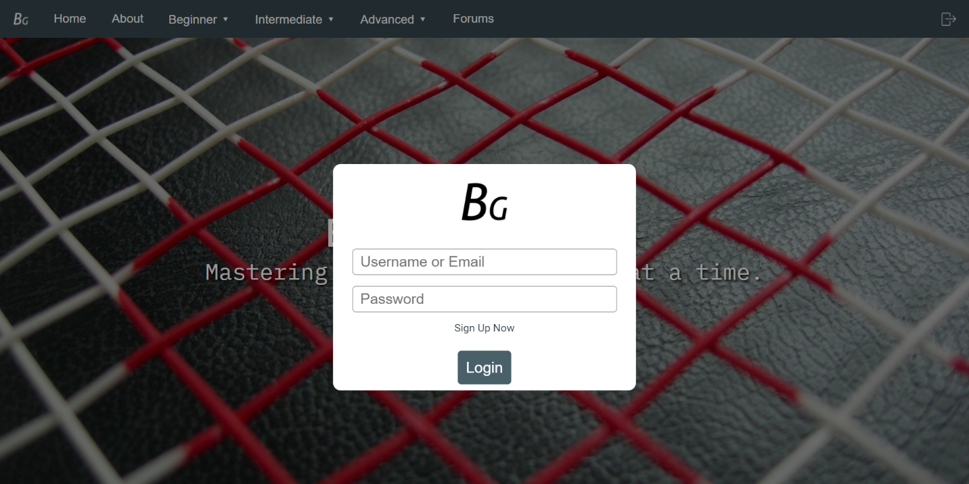

Figure 3: Login

After signup as a member of BadmintonGeek, visitor can click on the login button at the right top corner in order to log in into BadmintonGeek. Then the login form will show, visitor can input their registered username or email and password and click on “Login”.

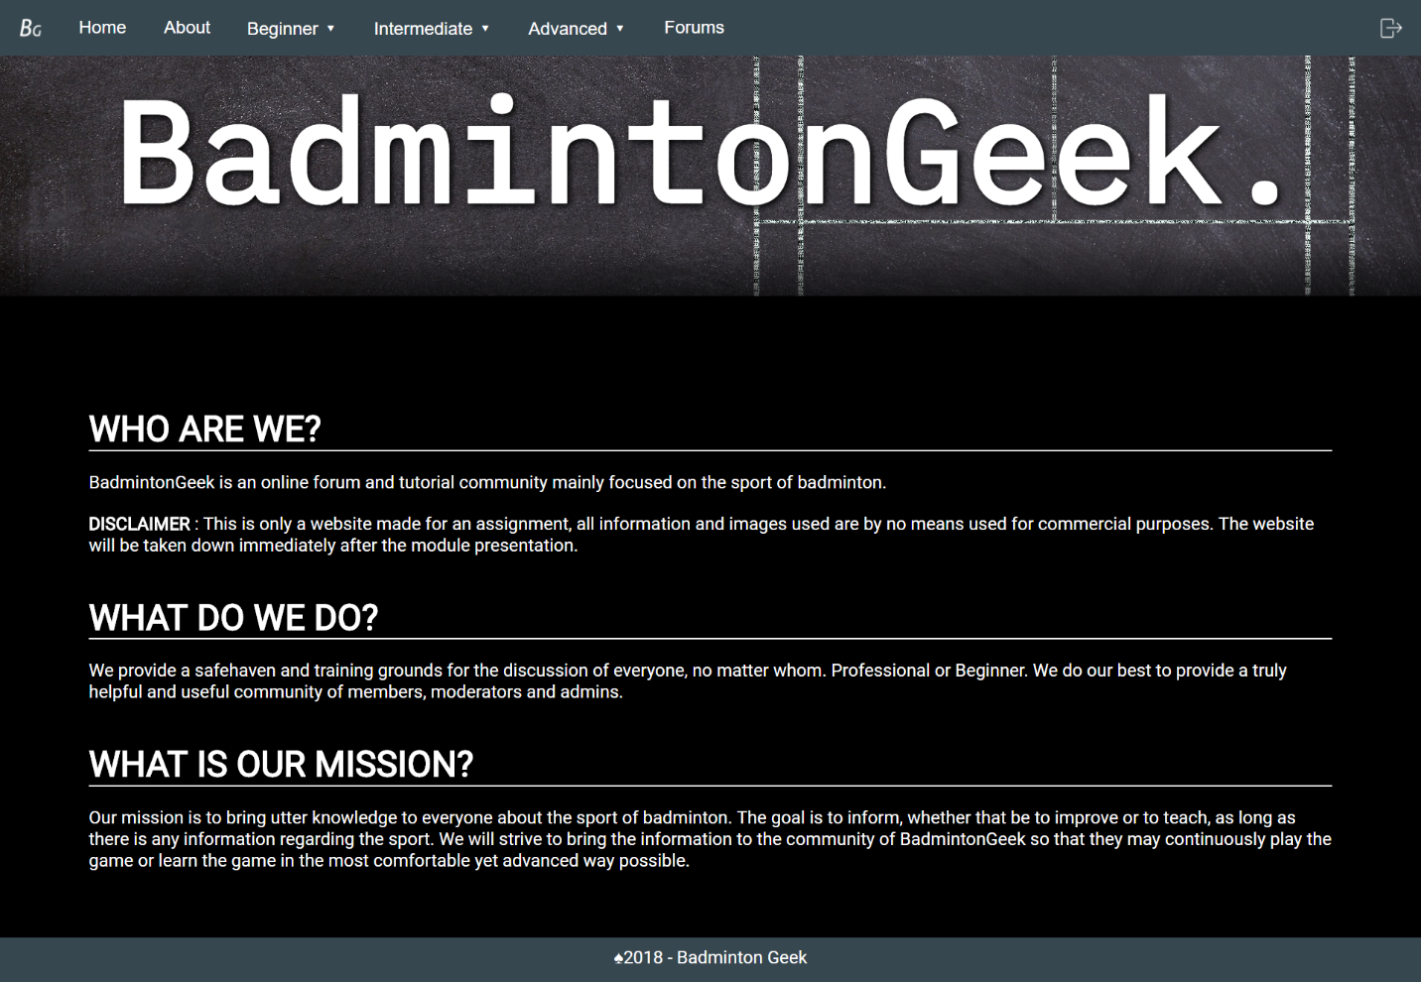

Figure 4: About

In the About page, you will see our website name again “BadmintonGeek” at the obvious top section of the webpage. In the About page, visitor will have deep understanding to BadmintonGeek after reading all the information porvided. About page tells the visitor who are BadmintonGeeks, what BadmintonGeek does and what is the mission of BadmintonGeek.

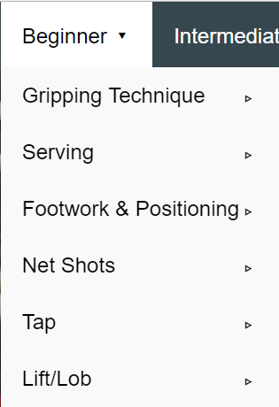

Figure 5:Beginner Level

On the navigation bar,you will see there are three different levels which includes beginner, intermediate and advanced. When visitor is intrested on the beginner related topics, he/she can click on “Beginner”. Then it will have the dropdown list as shown in Figure 5. Select the topic you want to find out more, a new window of the topic will show up.

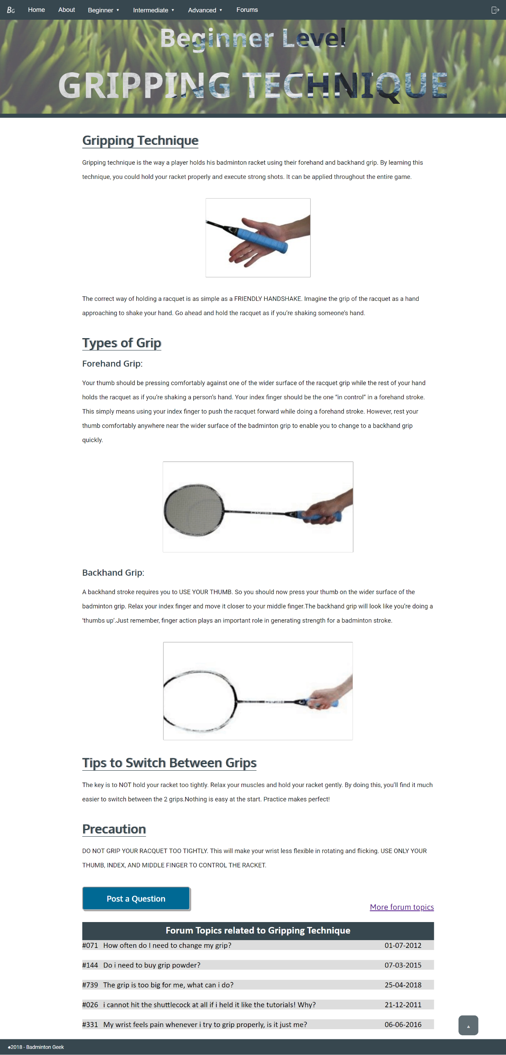

Figure 6:Beginner Level: Gripping Techechnique

On the Gripping technique webpage, you can see this topic is under beginner level as the header of this webpage had stated clearly the type of level and the topic.

In the content site, the title of this topic is again stated followed by the explanation of the topic. There are not only explanation in words but we also provided in picture .

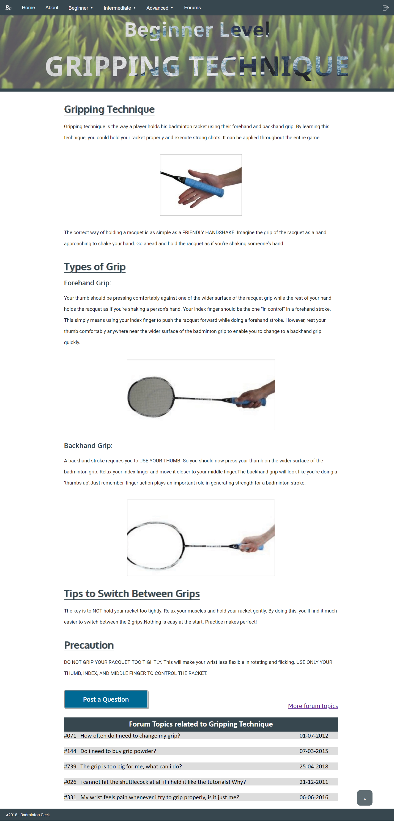It also shows there are two types of grip which are forehand grip and backhand grip. Each type of grip are explained in detail with picture attached.

Figure 7:Beginner Level:Gripping Technique

Besides, the webpage also provides some tips for the visitor how to swicth between these two types of grip, some precautions and advices on what visitor should be more focus on.

In the end of this topic, if thre reader have any question, they can click on the “Post A Questioin button” to ask the question in the forum. Visitors are advised to log in before posting any question on the forun. There is also list out the forum topics which are related to Gripping technique.

In order to back to the top of the webpage, visitor doesn’t required to scroll all the way up. Visitor just needs to clcik on the up arrow at the right botton to back to the top.

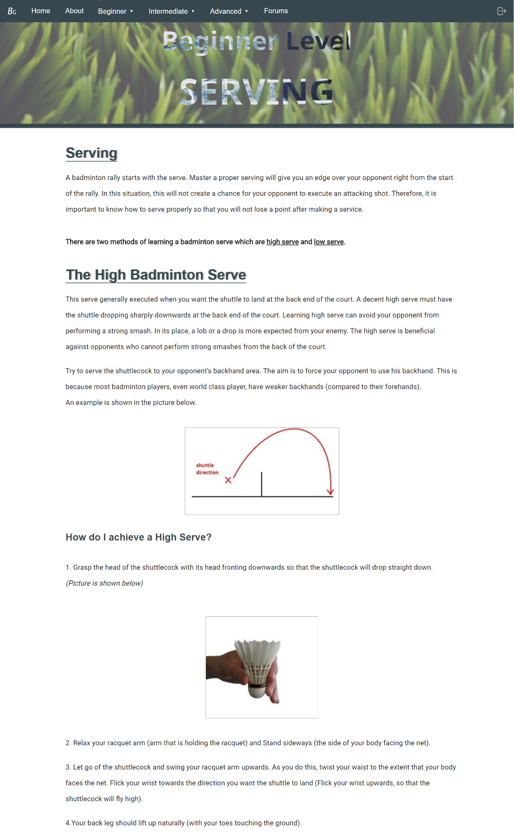

Figure 8:Beginner Level: Seving

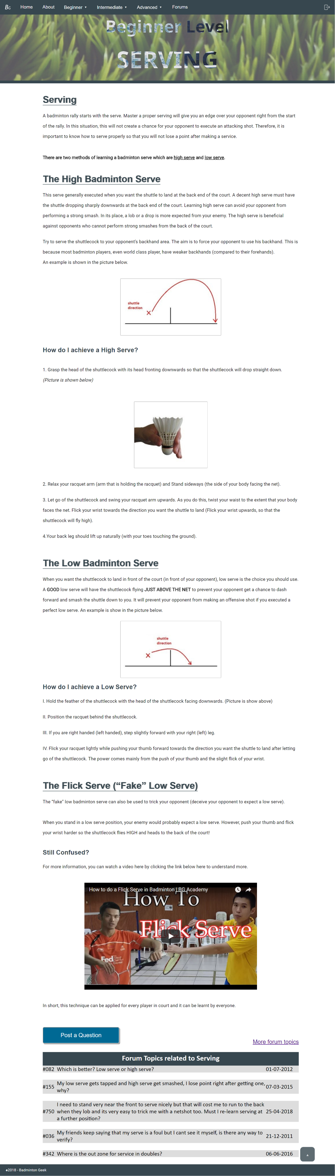

Figure 9: Beginner Level: Serving

Serving is one of the topics of beginner level. The title of this webpage and the level it belongs to will again stated on top of the webpage. The introduction of serving will start the content part. As there are two methods for badminton serve which are high serve and low serve, so each method will be introduced in details. High badminton serve and low badminton serve are both explained with example in picture and there are simple tutorials for visitor. The tutorials are step-by step with pictures attached on it.

Besides these two methods, the webpage also provided additional information for serving. It provides some trick for the reader such as The Flick Serve which also known as Fake Low serve.

For those reader who are still confused about serving or need more information related to serving, there are also a video about Flcik Serving provided. They also can discuss the question by posting it on forum with just one click on “Post Question” or check on the forum topics related to serving.

This webpage also has the “Back to Top” function at the right bottom of the site. A click on it can back to the top of the webpage easily.

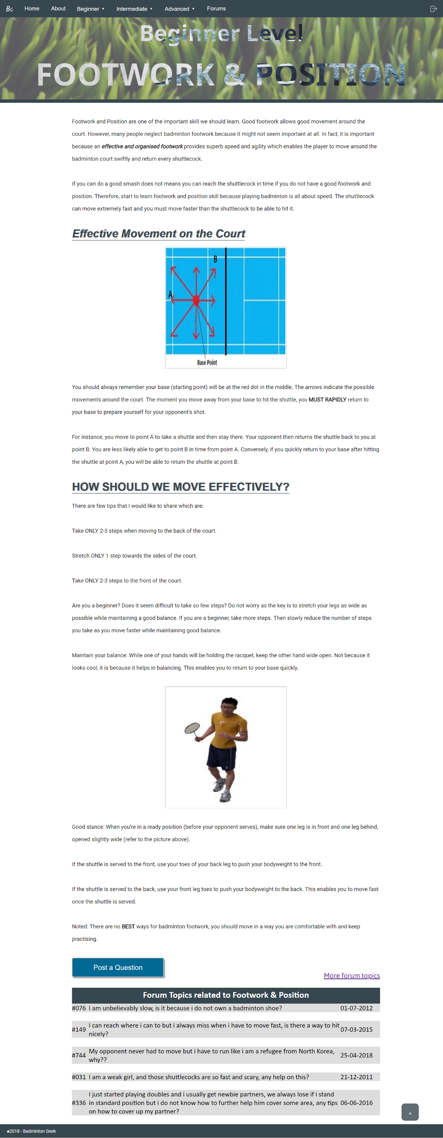Footwork and postion are also very important when you are still a beginner in Badminton. The “Beginner Level”and the title “Footwork and Position” are both stated on the top of the site.

Figure 10: Beginner Level: Footwork &Position

Then the web page start with the importance of footwork and position to badminton and how they affect on you while playing badminton.

It also shows what is the effective movement on the court. With the clear explanatioin and picture, visiotor can easily understand about effctive movement on the court. After have the basic understanding of it, next there are tips for visitors on how to move effectively.

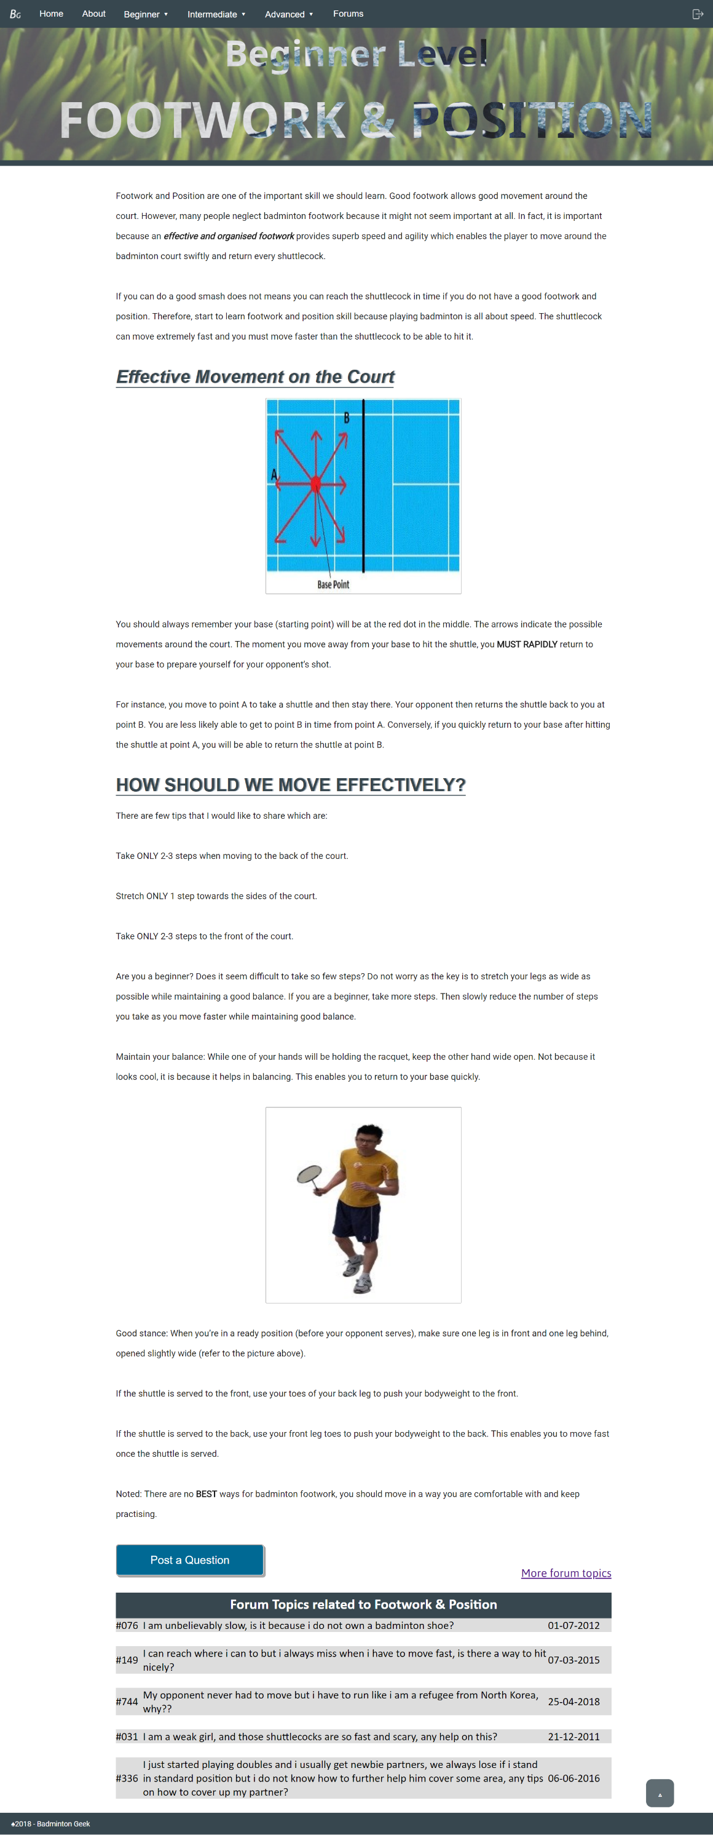The few tips provided are clear and easy to understand. It also consider as a beginner, it might be difficult to adopt it so there also also some alternative ways for the beginner while they are trying for the badminton footwork. There is also picture for visitor to know exactly what is ready position with detailed explanation. A reminder also provided for visitor in oder to advice them about footwork and position while playing badminton.

Figure 11:Beginner Level: Footwork& Position

If visitors have question about Footwork and Position, the website has prepare for them to post question and discuss on forum. Hence, just click on “Post A Question” button to post your doubt about this topic.

The webpage also doesn’t require scrolling to back to the top of the page. As this can be done by simple clicking on the arrow button that provided at the right bottom of the page.

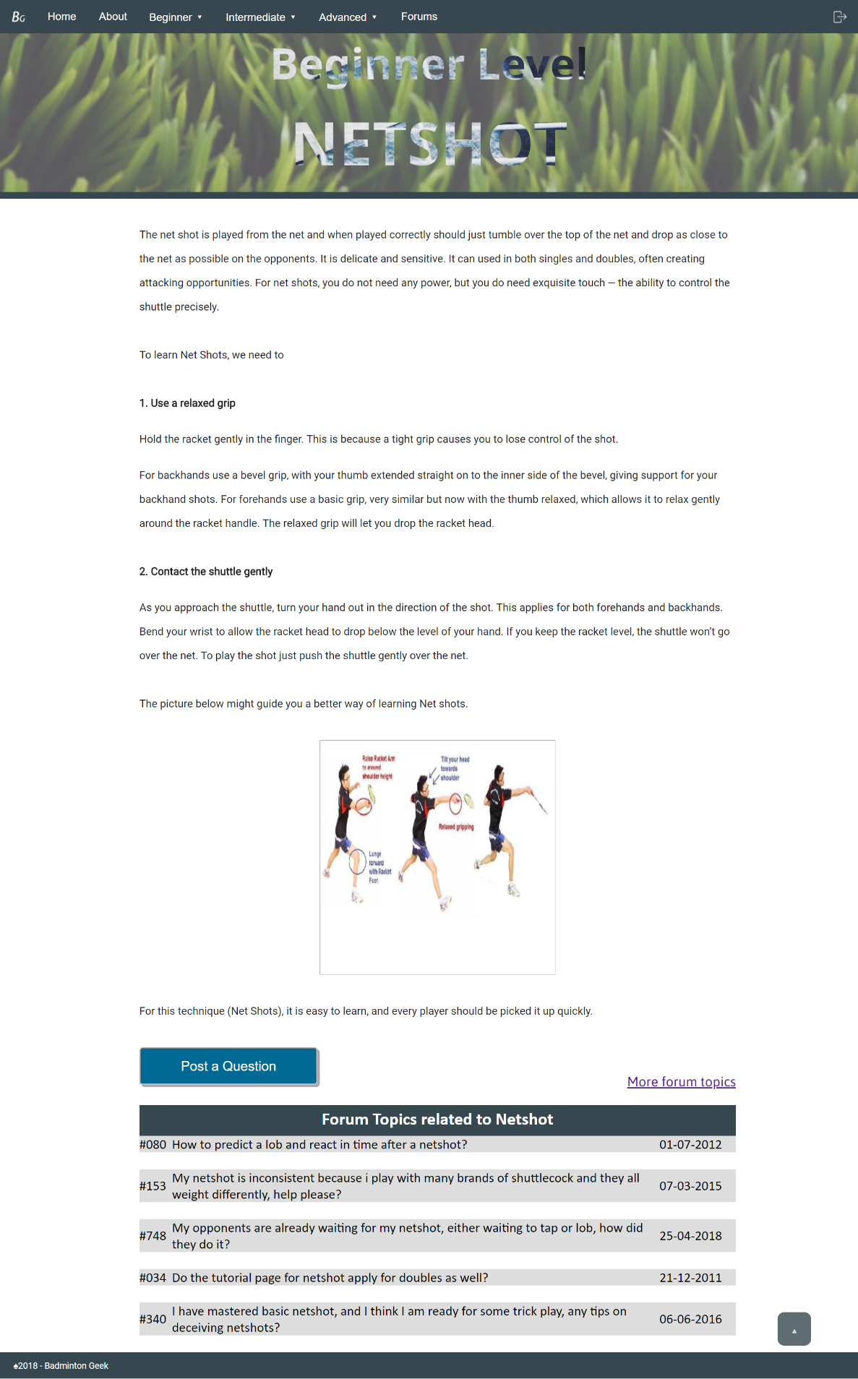Netshot is a basic techinique that a beginner should master. As what previous webpage did, the level that netshot is belongs to which is “Beginner Level” and the topic “Netshot” also shown at the top of the page.

Figure 12: :Beginner Level: Netshot

At the beginning of the page, you will know about what is netshot as webpoage had explained it at first. To master Netshot, there are only two steps. Each of the steps has very detailed information and there are picture provided in order to guide reader in learning Netshot.

If reader still have any question or not so clear about Netshot, they are always welcome to click on the “Post a Question” button to post their question to forum that related to Netshot. They also can find the solution from the forum.

When you want to revise the information on top, you can just click on the arrow button to back to the top of the website which consume the time from scrolling all the way up.

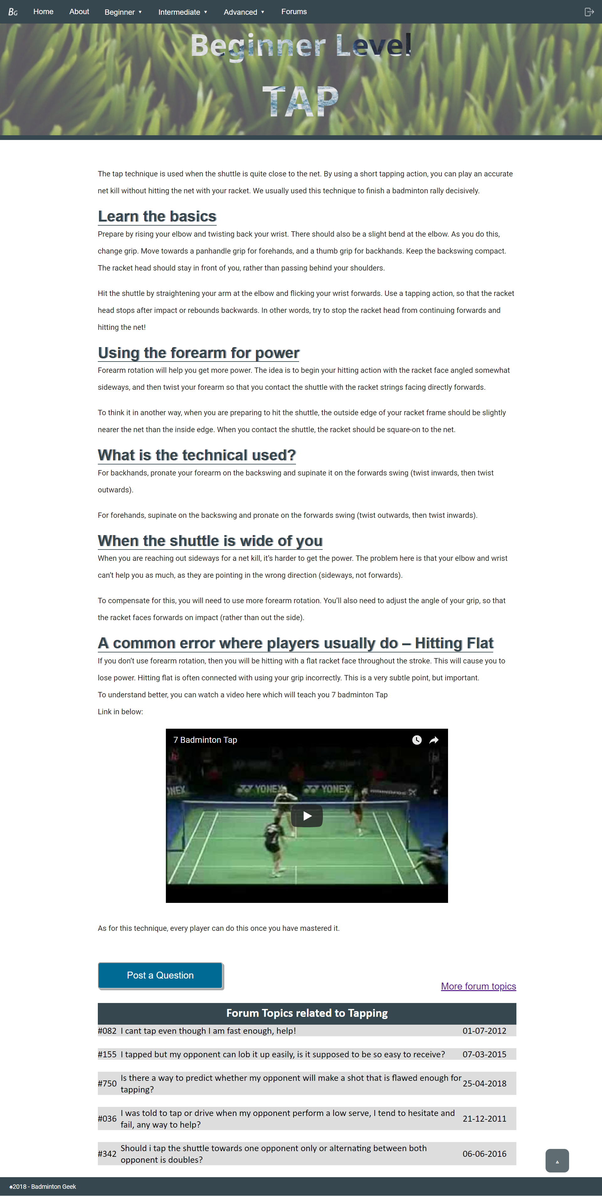.

Figure 13: :Beginner Level: Tap



Figure 14: :Beginner Level: Tap

Under beginner level there are so many technique to be learned and one of them is Tap. As usual, on the top of the webpage there are “Beginner Level” and “Tap” indicate the topic of this webpoage is Tap. At the beginning, the webpage described breifly what is tap and what is the function of this technique. The the webpage is followed by the basic of Tap and how to perform this technique. It also mentioned that the forearm rotation is very important in Tap as it will help to gain more power.

The technical used in forehands and backhands gripping are different. Hence, the details of this are also clearly on the weboage. There are also different assumption for the situation and there are solution for each situation the reader may faced. At the end of the content, it mentioned about that Hitting Flat possible happen if the player don’t use forearm rotation in Tap. A video about tap also provided for visitor to have deeper understanding in Tap.

If visitor has any doubt or interested in this topic, they can discuss or post a question on forum by clicking on “Post A Question” at the bottom of the webpage. There is also “Back to Top” function available at the right bottom corner of the webpage for visitor’s convenience.

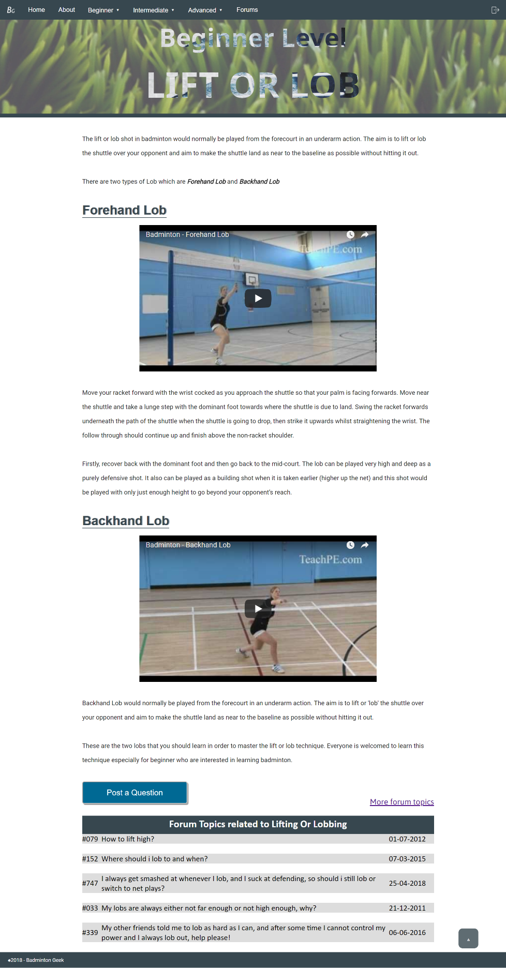

Figure 15: :Beginner Level: Lift or Lob

The last topic that will be discuseed under beginner level is Lift or Lob. The title and the level of this topic are stated on top of the webpage.

In the content, there stated in which situation this tecnique will be used. Besides, the purposes of using this technique also shown at the beginning of the content.

There are two types of Lob and each types of lob are being explained in very detailed. The way of using this tecnique while playing badminton, which situation is more suitable for the lob and the uses of the lob are describe clearly. In case, the reader still not understang about both types of Lob, the webpage also provides videos for each lob.

In order vsitors interested in this topic or have question, a button of “Post a Question” is provided at the bottom of the page. Visitor also can check the previoius dicussions in Forum that has related topic.

At the right bottom of the webpage, there is a small arrow porvided for visitor to back to the top of the webpage easily.

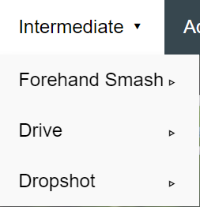

Figure 16: Intermediate Level

When visitor is intrested on the intermediate level related topics, he/she can click on “intermediate” on the navigation bar. Then it will have the dropdown list as shown in Figure 16. Select the intrested topic, a new window of the topic will show up.

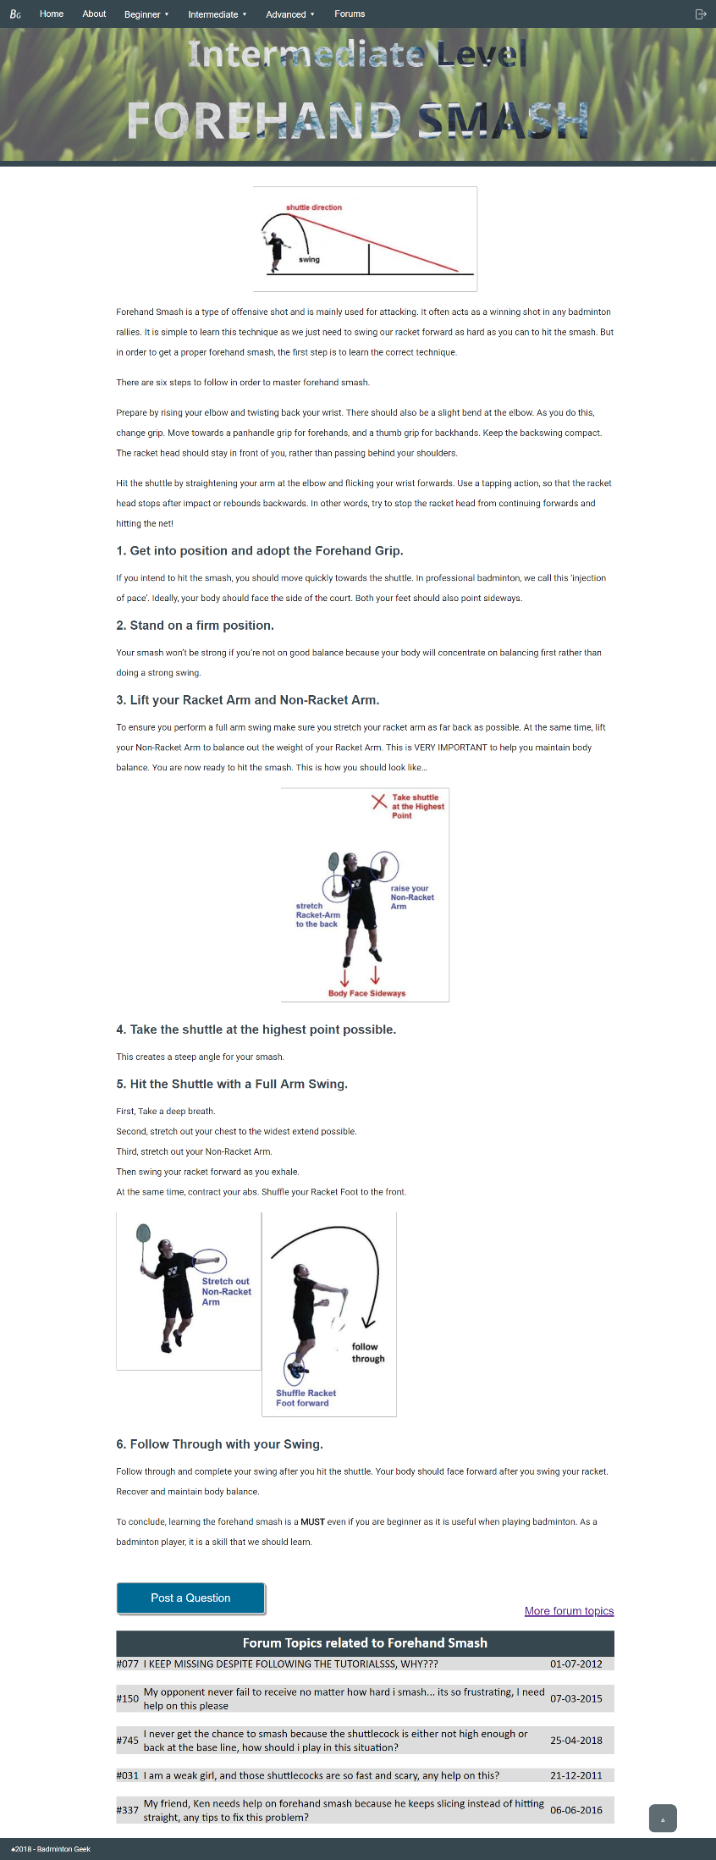

Figure 17:Intermediate Level: Forehand Smash

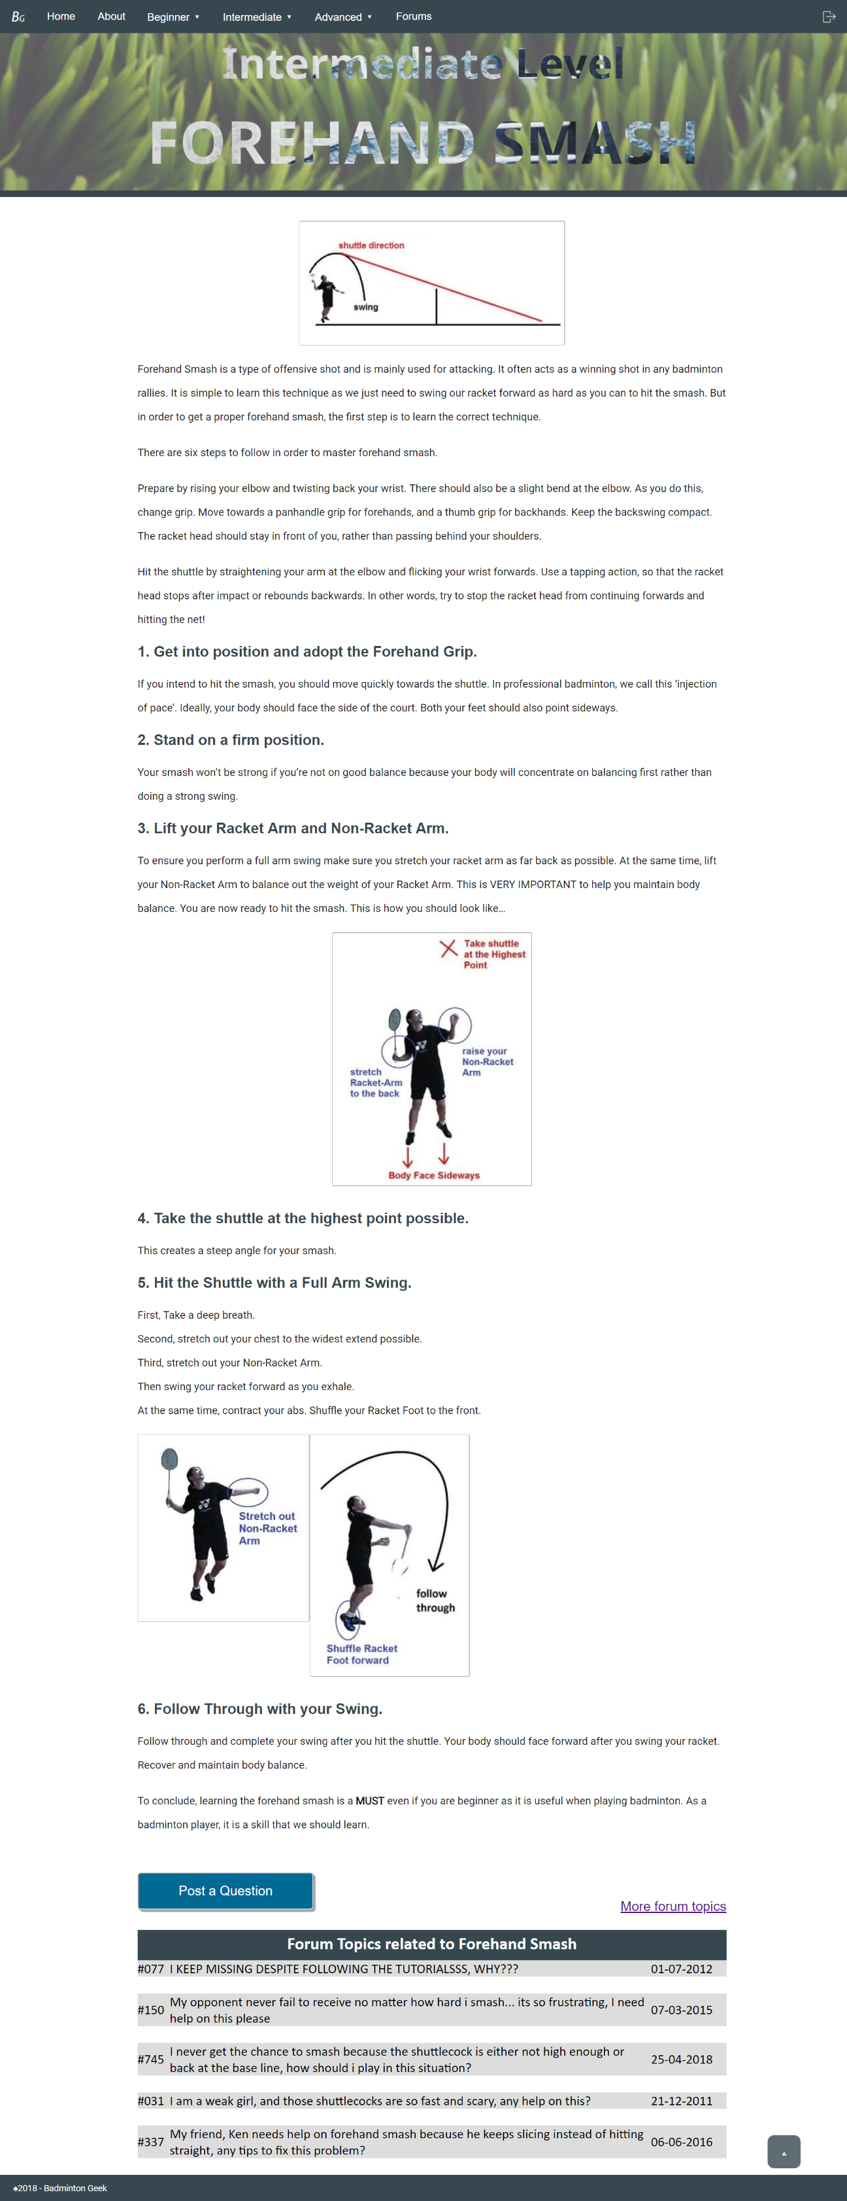In Intermediate Level there are three types of technique. One of the technique is Forehand Smash. The level of forehand smash and the title are staed on top of the webpage.

Figure 18: Intermediate Level: Forehand Smash

First, the webpage introduced you about forehand smash with a picture. From the picture, reader can know clearly what is forehand smash. Then, there are a very detailed introduction about this technique.

As to master forehand smash, there have six steps to follow. Each step are explain in brief but easy to understand. Some of the steps also have picture atteched and some descriptions labeled on the pictures.

If the visitor still have any doubt to be solved, they are welcomed to click on the “Post A Question” button. Besdies, they also can search for similar discussion from the forum. As other webpage, this webpage also have the back to top function. Visitor can just click on the arrow at the right bottom to back to the top of webpage.

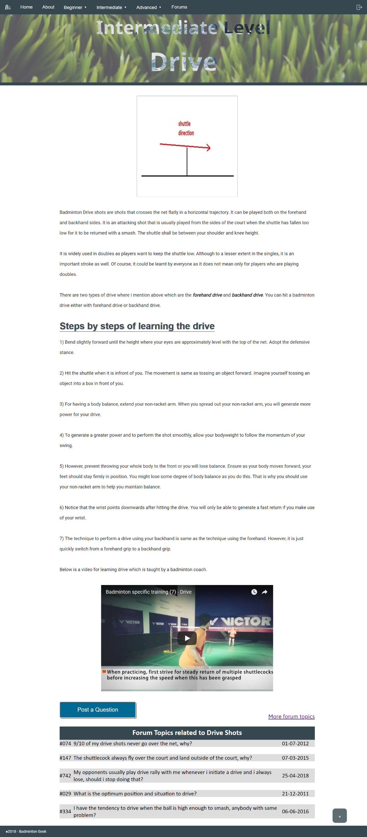

Figure 19:Intermediate Level: Drive

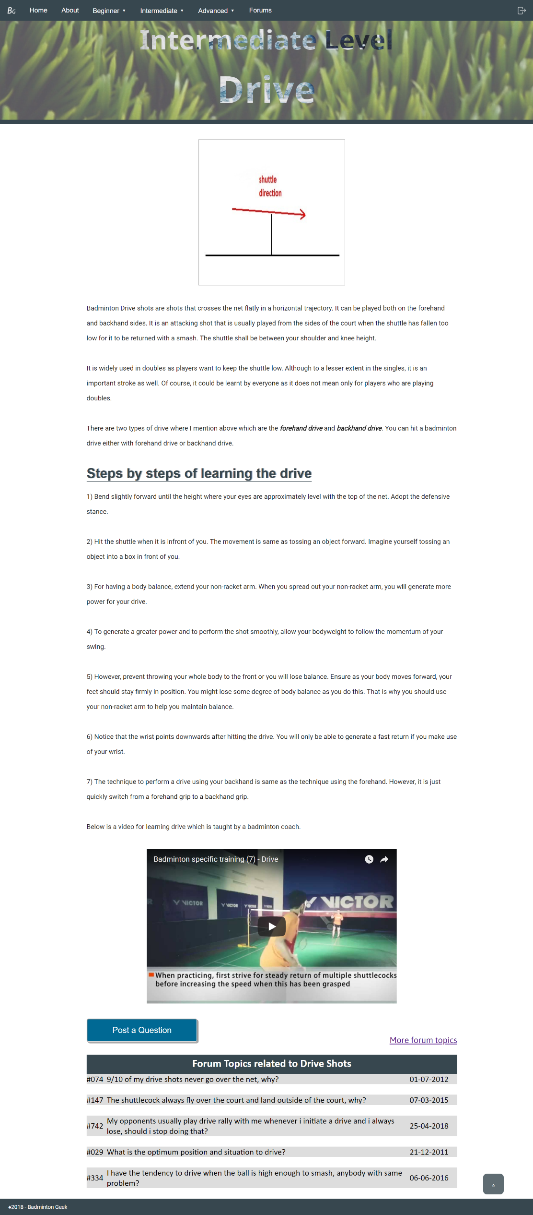The next topic that is under intermediate level is Drive.

Figure 20:Intermediate Level: Drive

“Intermediate Level” and “Drive” are both in the top of the webpage. A picture is attached with the introduction of Drive at the beginning of the webpage. There are two types of drive which are forehand drive and backhand drive. This technique not only used on player who plays double but also single.

In order to master Drive, there are seven steps to followed. Each steps are explained clearly in the step-by – step tuorial. If the reader still not understanding about Drive, there is a video regarding driive technique training provided for them.

Reader can also chose to post a quesiton by clicking on the “Post a Question” button or check on the previous forum to solve their doubt. There also doesn’t require scrolling to back to top as there is a small arrow provided at the right bottom corner. A simple click on the arrow can consume the time of visitor from scrolling the webpage.

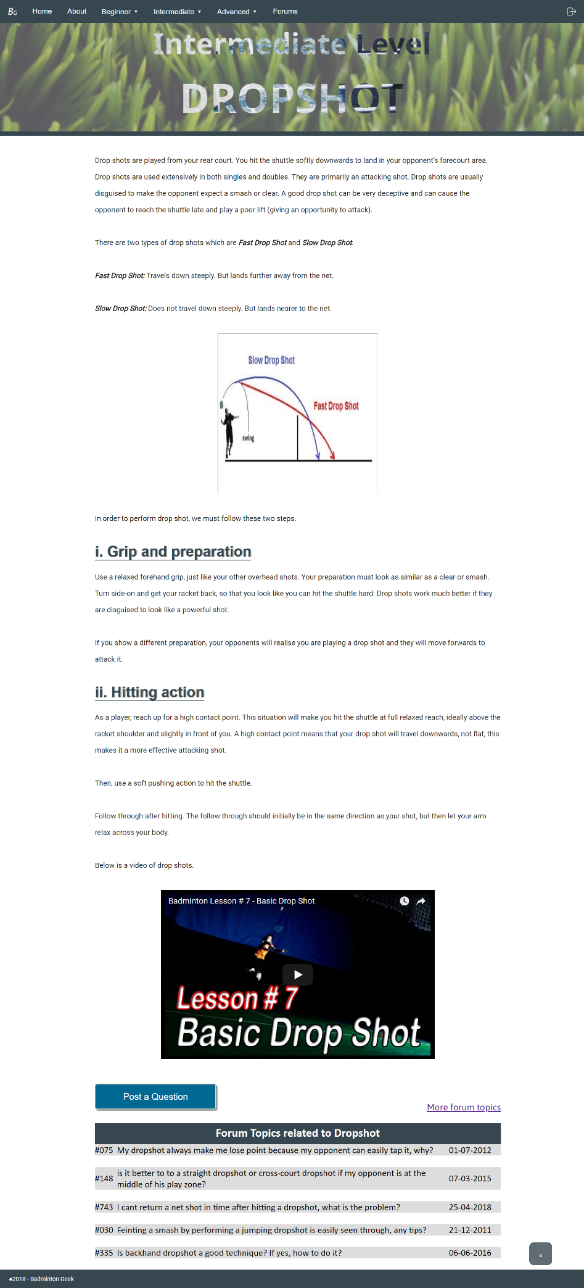

Figure 21:Intermediate Level: Dropshot

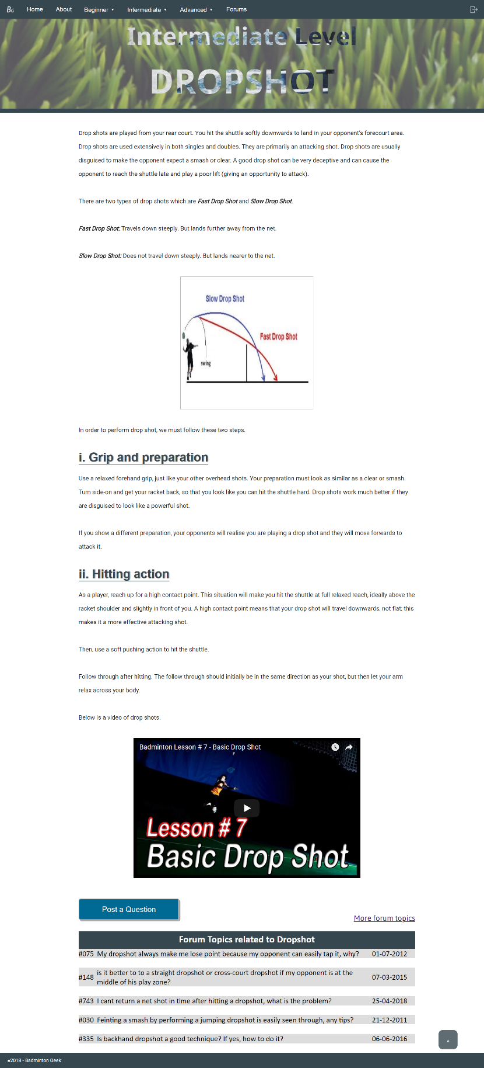Dropshot is the last topic in Intermediate Level. As previous webpage, the level of this webpage belongs to and the topic are shown at the top of the weboage. Then, the introduction of Dropshot. The introduction includes the uses of this technique and what is the benefit from a good dropshot. Besides, there are two types of drop shtos which are Fast Drop Shot and Slow Drop Shot.Both drop shots are explained in breifly and there is a picture that shows the difference of these two types drop shot.

Figure 22:Intermediate Level: Dropshot

To perform a good grop shot, there are two ways to followed.These two ways are explained in detailed to let reader can understand them easily.The webpage also provides ashort video regaridng Drop Shot to ensure visitor has clearly understand about dropshot.

A “Post a Question” button also provided for visitors to post their doubt and discuss in the forum. There are also few forum topics that relate to dropshot shown.

The “Back to Top” function also unsurpirsingly available in this page for the conveniece of the visitor.